Sysc 3303 Project Iteration 4

**Rate Monotonic Analysis:**

|  |  |  |  |  |
| --- | --- | --- | --- | --- |
| **Process** | **Period T (ms)** | **Computation Time C (ms)** | **Utilization C/T** | **Priority** |
| Arrival Sensors Interface | 50 | 0.67 | 0.0134 | 1 |
| Elevator Buttons Interface | 100 | 0.18 | 0.0018 | 2 |
| Floor Buttons Interface | 200 | 7.8 | 0.039 | 3 |

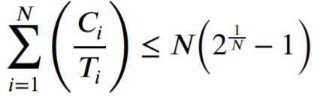

***N(21/N -1) => N=3 (3 Processes)***

=> 3(21/3 -1)= 3(1.2599 -1)= 3(0.2599)= 0.7797= 77.97%

= C Arrival Sensors Interface/ T Arrival Sensors Interface + C Arrival Sensors Interface/ T Arrival Sensors Interface + C Arrival Sensors Interface/ T Arrival Sensors Interface

= 0.0134/50 + 0.0018/100 + 0.039/200= 0.0542

Since 0.0542 is less than 0.7797 than there is no issue with completing the processes